Injury / Fall / Choking Incident Report
Instructions for completing form:
- Type or print legibly. Complete all sections. Mark section NA if not applicable.
- Complete form and route it directly to the Health Support Nurse by the next business day.
- Do not assume that your co-workers will see this report. Follow departmental procedure to inform co-workers.
Injury Fall Choking
Consumer:
Reporter’s Name (please print):
Date of Occurrence: |  |  |  | Time:
Location at time of occurrence:
Describe what happened:

Was any treatment received:

Circle and number the areas on the below drawing of a human form where abnormal skin conditions and/or color exists. Document the details below:
# | Time |  | Description (use color, size, and specify bruise, scab, scratch, etc.)
Do you have suggestions for minimizing reoccurrence?
Do you need your supervisor’s help in following up with this? Yes No
Reporter’s  Signature: |  |  |  |  | Date:
Front Back
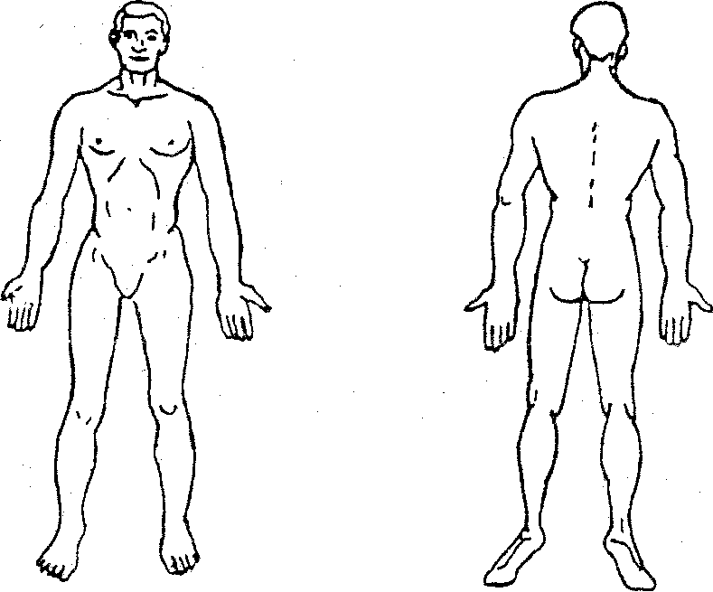
HS Nurse reviews the report, assesses Consumer (if deemed necessary) and generates a Med Note to the Consumer’s Cottonwood support team. If outside TCM and/or non-Cottonwood Designated Healthcare Coordinator then a separate Med Note is sent to the appropriate party. If the form is completed by Cottonwood Day Services staff, the Consumer’s Work Services/Life Enrichment Coordinator (or proxy) contacts the Consumer’s non-Cottonwood Designated Healthcare Coordinator.
- HS Nurse stamps the report “Original”, signs/dates report, and routes it to the following:
Title | Signature | Date
Health Supports Nurse
CEO
Administrator of Services
Support Services Director
Return completed Injury/Fall/Choking Incident Report to Case Manager for Case Record

