Skin Assessment Form
To be used to report skin issues of suspected or unknown cause

Consumer’s Name: ____________________________________ Date: _________________
Reporter’s Name and Department (print): _________________________________________
Reporter’s Signature: _________________________________________________________

Circle and number the areas on the below drawing of a human form where abnormal skin conditions and/or coloration exists.
# | Time | Description: use color, size, and specify bruise, scab, scratch, etc.
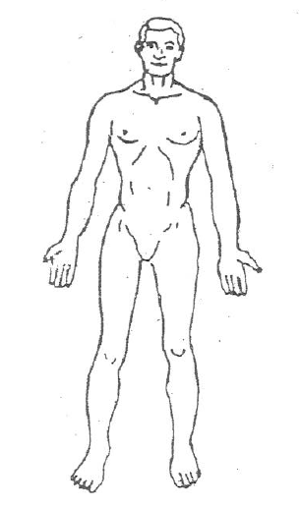
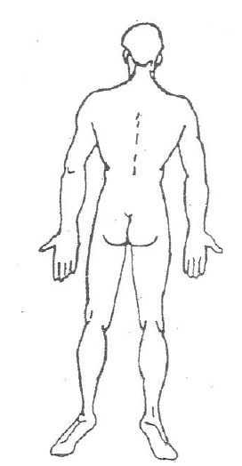
FRONT BACK

Comments/Narrative: (Do you know what caused this?) _______________________________________ ________________________________________________________________________________________________________________________________________________________________________
Route completed form directly to Health Support Nurse.
Health Support Nurse reviews form, assesses Consumer (if deemed necessary), and generates a Med Note to the Consumer’s Cottonwood support team.

